**Redshift Assignment**

**Problem Statement:**

**You work for XYZ Corporation. Their application requires a database service that**

**can store data which can be retrieved if required. Implement suitable service for**

**the same.**

**While migrating, you are asked to perform the following**

**tasks:**

**1. Create a Redshift data warehouse.**

**2. Using the query editor:**

**a. Load some data**

**b. Query the data**

1. Created a redshift data warehouse

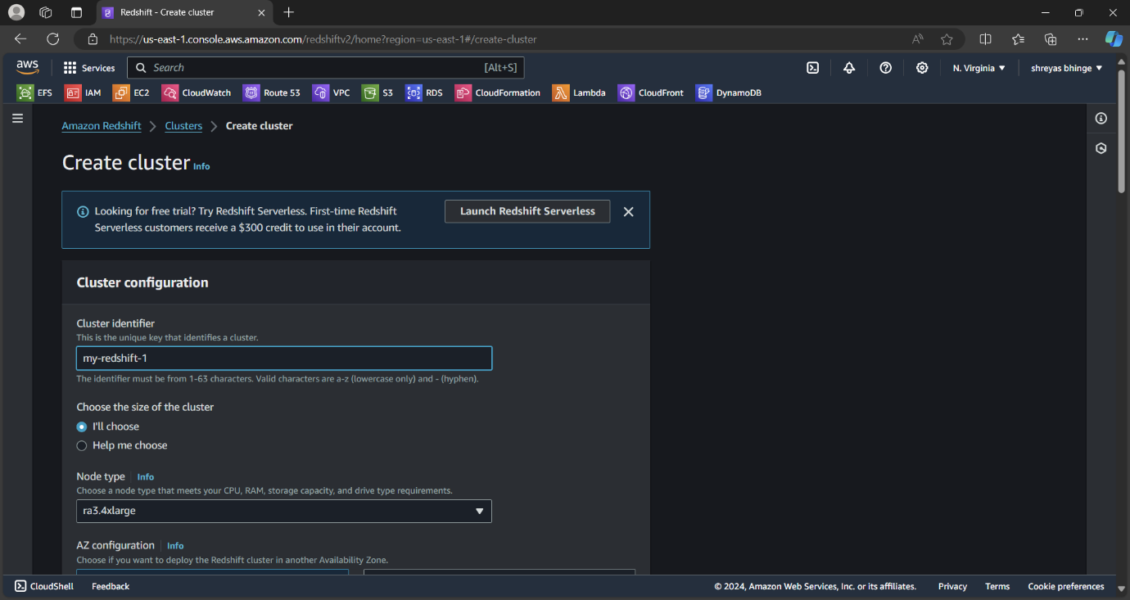

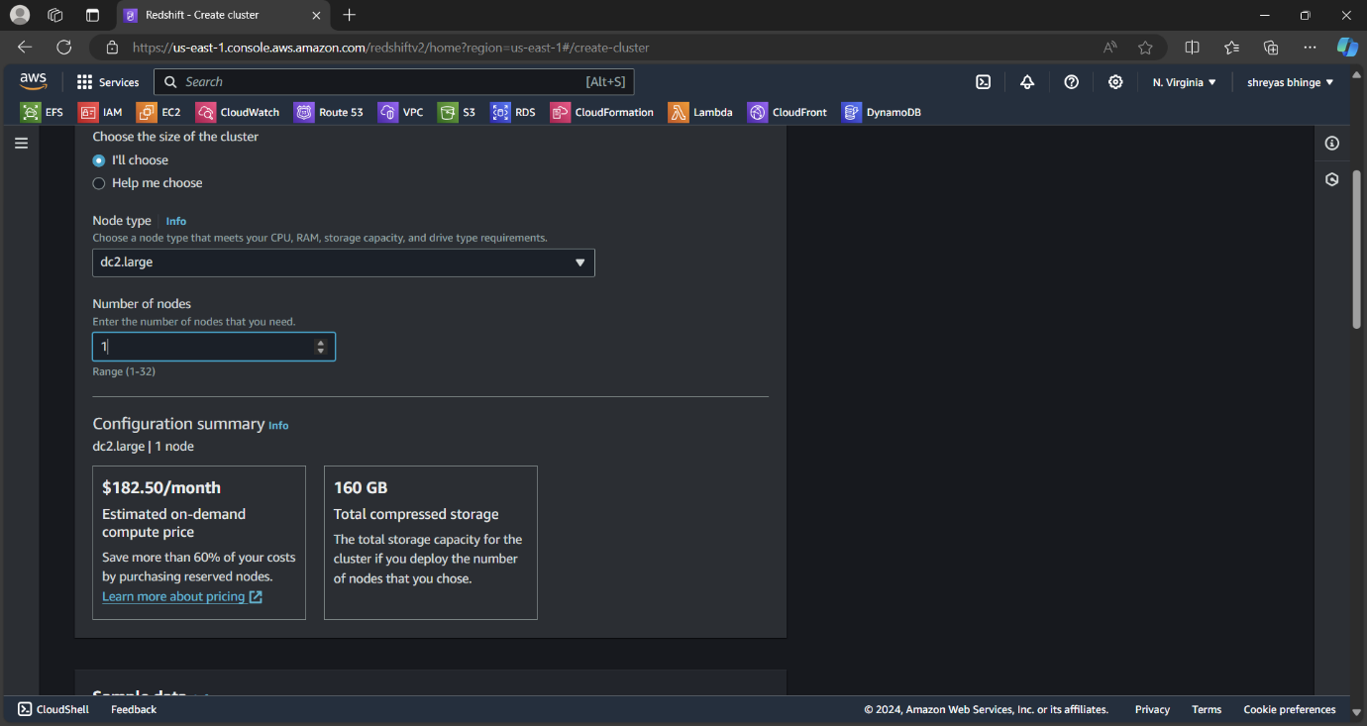

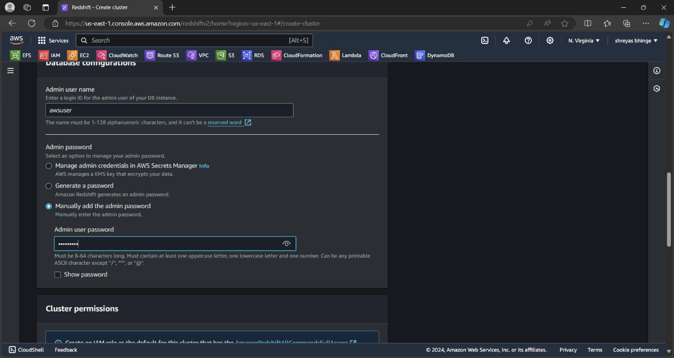

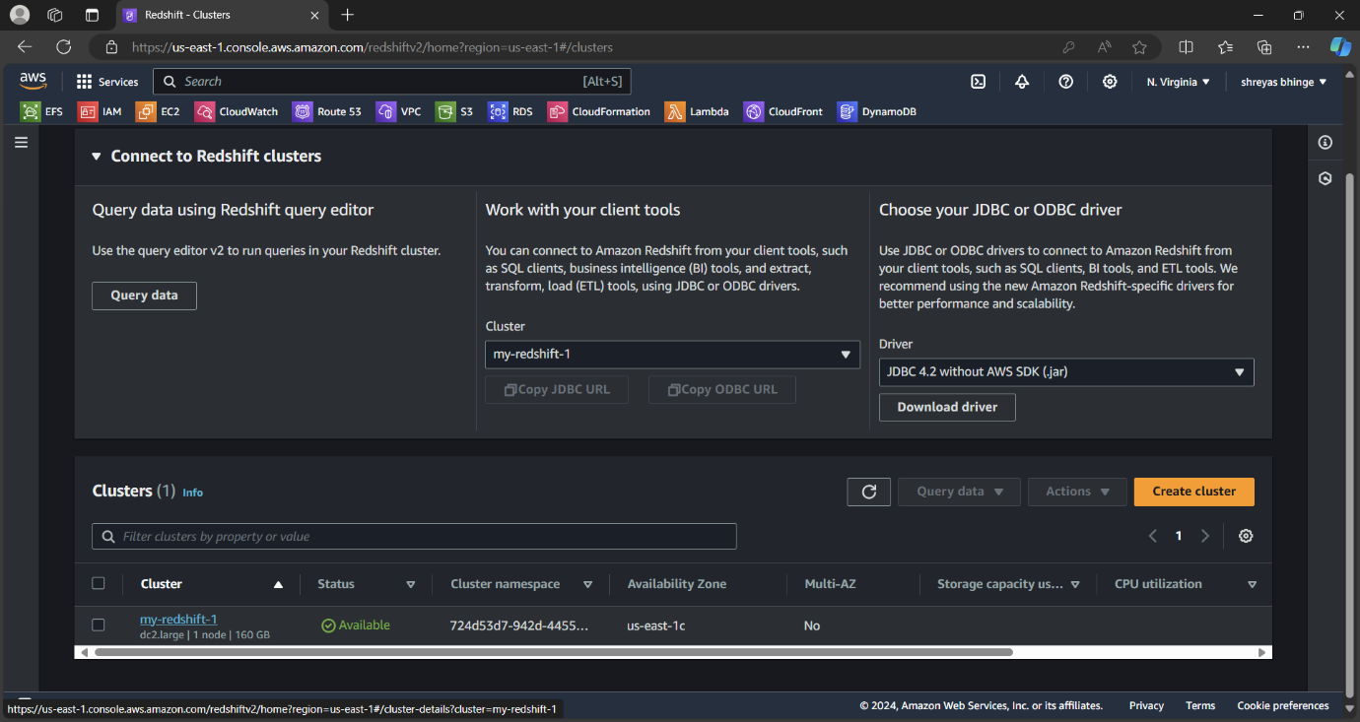

2. Using the query editor v2

